**PROBLEM STATEMENT ON BP MONITORING**

* It is important to get an accurate BP reading so that you have clear picture pf your risk for heart disease of stroke.
* In order to solve a problem, we need to realise that is exists, we need to appreciate its important and we need a solution. This is only too evident to clinicians treating a symptomless risk factor like hypertension.
* The patient is generally unaware that there is a problem. Simply recognising that our patient has high blood pleasure is not sufficient.
* We need him to understand that his high blood pressure has real consequences for his future health. Only then will he consider taking treatment.
* Accurate and reliable blood pressure (BP) measurement is critical for the proper diagnosis and management of hypertension, So much so that a 5mm HGBP measurement error can lead to incorrect hypertension classification on 84 million individuals worldwide, according to a position statement published in the journal of hypertension, understanding the ways BP measurement goes wrong, and how to tackle them, can improve diagnosis and management of hypertension.
* Due to digital BP measurement if body movement or an irregular heart rate can affect its accuracy, some models only work on the left arm this can make them hard for some patients to use.

**Requirements:**

* BP device
* EOS Sensor
* Raspberry pi with 8GB
* Monitor/Display unit

**Block Diagram of BP measurement digital**

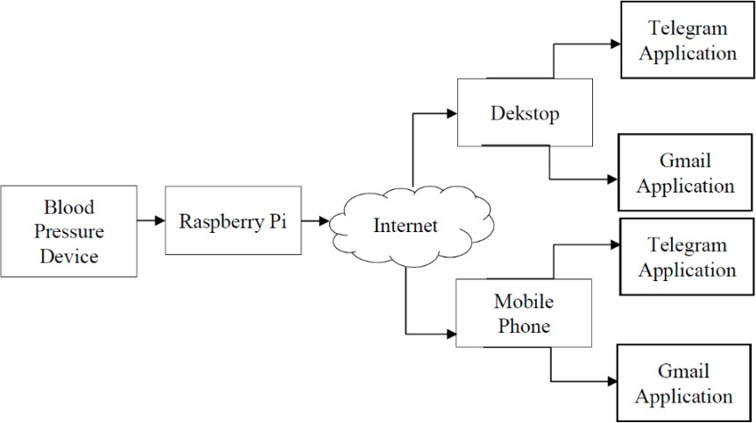

**Flow Chart**

